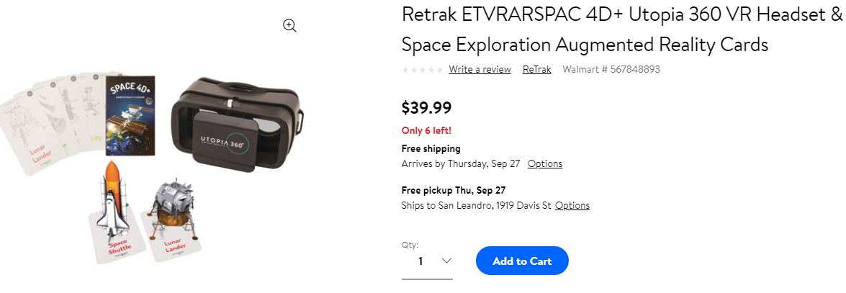
About This Item
We aim to show you accurate product information. Manufacturers, suppliers and others provide what you see here, and we have not verified it. See our disclaimer
Embark on an out-of-this-world adventure with ReTrak's 4D+ Utopia 360? VR Headset and Space Exploration Augmented Reality Cards bundle. Capture fun augmented reality photos of planets and other space objects in your real-world environment and immerse yourself in a 360deg VR experience surrounded by the vastness of outer space. The bundle includes a Utopia 360deg VR headset and 26 interactive cards for an immersive 4D experience.
Works with The Interactive & Fully Featured Space 4d+ App
Explores 3d Library As Well As Facts About Planets, The Solar System, Space Objects & Space Missions
Captures Fun Augmented Reality Photos of Space Objects In Real-world Environments
Ideal for Ages 7 & Up
Includes Utopia 360? Vr Headset & 26 Ar Cards
Specifications
Brand: ReTrak
Condition: New
Color: Multicolor
Model: ETVRARSPAC
Manufacturer Part Number: ETVRARSPAC
Assembled Product Dimensions (L x W x H) 0.10 x 4.80 x 5.50 Inches

